|  |  |
| --- | --- |
| Logo_FPT_University_doc |  |

|  |
| --- |
| **FPT UNIVERSITY** |
| Capstone Project Document |

USEFUL JAPANESE DICTIONARY FOR VIETNAMESE

Screen design

Project code: UJD\_VN

Document code : UJD\_VN\_Screen design\_v1.1

- Hanoi, 06/2014 –

Record of change

\*A - Added M - Modified D – Deleted

|  |  |  |  |  |
| --- | --- | --- | --- | --- |
| Effective Date | Changed Items | A\* M, D | Change Description | New Version |
| 23/06/2014 | Screen design | A | Create new | v0.1 |
| 30/06/2014 | Screen design | M | Update screen | v1.0 |
| 11/08/2014 | Screen design | M | Update screen | v1.1 |
|  |  |  |  |  |

**Signature page**

**Riginator** Nguyễn Ngọc Tuấn 23/06/2014

Team member

**Reviewer**  Nguyễn Ngọc Tuấn

Team member

**Approval** Nguyễn Văn Sang

Supervisor

Table of Contents

[1 Introduction 4](#_Toc395588777)

[*1.1* Purpose 4](#_Toc395588778)

[*1.2* Definitions, Acronyms and Abbreviations 4](#_Toc395588779)

[*1.3* Overview 4](#_Toc395588780)

[2 Screen Flow 5](#_Toc395588781)

[*2.1* Search screen 5](#_Toc395588782)

[*2.2* Login 6](#_Toc395588783)

[*2.3* Register 7](#_Toc395588784)

[*2.4* Edit profile 9](#_Toc395588785)

[*2.5* Forgot password 10](#_Toc395588786)

[*2.6* Contribute content 11](#_Toc395588787)

[*2.7* Contribute opinion 12](#_Toc395588788)

[*2.8* Send Q&A 13](#_Toc395588789)

[*2.9* Test 14](#_Toc395588790)

[*2.10* Training listening 15](#_Toc395588791)

[*2.11* Conversation 17](#_Toc395588792)

[*2.12* Reading 19](#_Toc395588793)

[*2.13* Management Member’s account 19](#_Toc395588794)

[*2.14* Vocabulary management 20](#_Toc395588795)

[*2.15* Grammar management 24](#_Toc395588796)

[*2.16* Reading document management 26](#_Toc395588797)

[*2.17* Conversation management 30](#_Toc395588798)

[*2.18* Video management 35](#_Toc395588799)

[*2.19* Training listening management 36](#_Toc395588800)

[*2.20* Doing test management 39](#_Toc395588801)

[*2.21* Contact management 43](#_Toc395588802)

[*2.22* Approve contribute content 45](#_Toc395588803)

[3 Other considerations 49](#_Toc395588804)

# Introduction

## Purpose

To ensure consistency and simplicity in detailed design across all displays within a product interface, as well as across other products used by the same users.  Definitions, acronyms, abbreviations, references and overview of UJD\_VN website

## Definitions, Acronyms and Abbreviations

|  |  |  |
| --- | --- | --- |
| Abbreviations | Description | Comment |
| UJD\_VN | Useful Japanese dictionary for Vietnamese |  |
| Q&A | Question and answer |  |
|  |  |  |
|  |  |  |

## Overview

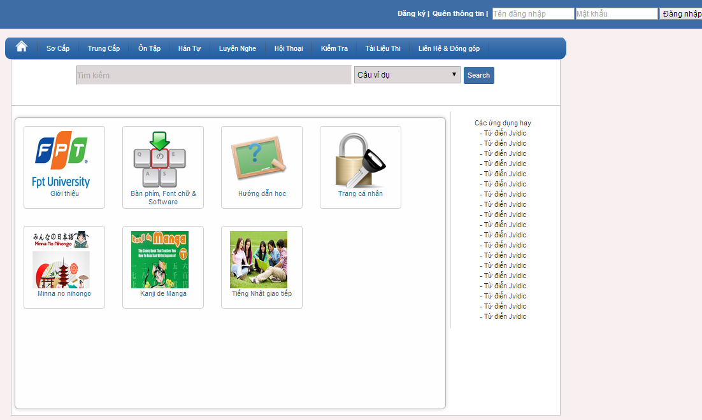

# Screen Flow

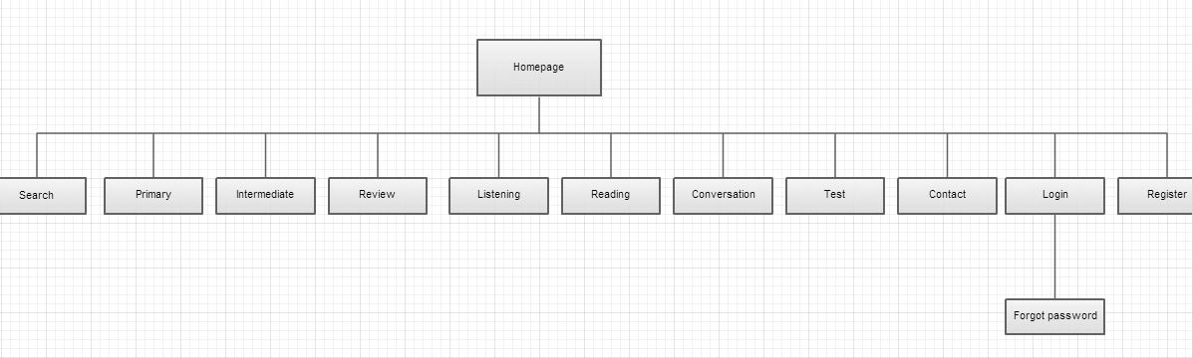

|  |  |  |
| --- | --- | --- |
| No | Screen Name | Description |
| 1 | Homepage | Homepage |
| 2 | Primary | Primary lesson |
| 3 | Intermediate | Intermediate lesson (level N3, N2) |
| 4 | Review | Review lesson |
| 5 | Listening | Listening lesson |
| 6 | Reading | Reading lesson |
| 7 | Conversation | Conversation lesson |
| 8 | Test | Doing test (level N4,N3,N2) |
| 9 | Contact | To contact with UJD administrator |
| 11 | Login | Login as a member |
| 12 | Forgot password | Contact to admin to receive password |
| 13 | Register | Create new account |
| 14 | Search | Search |

## Search screen

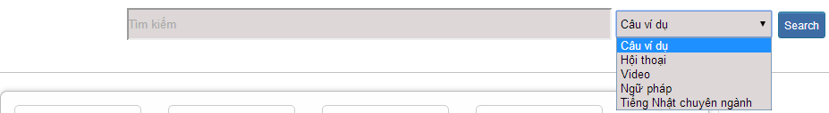

Figure 1: Search

Table 1: Search’s screen description:

|  |  |  |  |  |  |  |  |
| --- | --- | --- | --- | --- | --- | --- | --- |
| No | Field name | Field name in Vietnamese | Type | Require | Mandatory | Max-Length | Description |
| 1 | Searcharea | Tìm kiếm | Text | Text | Y | 255 | User input a new word with length less than 255 characters |
| 2 | SearchOption | Kiểu tìm kiếm | Drop-down list | Click | Y |  | User choose type of search |
| 2 | Search | Search | Button | Click | Y |  | User click on search button |

## Login



Figure 2.1: Login

Table 2.1: Login’s screen description:

|  |  |  |  |  |  |  |  |
| --- | --- | --- | --- | --- | --- | --- | --- |
| No | Field name | Field name in Vietnamese | Type | Require | Mandatory | Max-Length | Description |
| 1 | Username | Tên đăng nhập | Text | Text | Y | 32 | User input username with length less than 32 character |
| 2 | Password | Mật khẩu | Password | Text | Y | 32 | User input their password with length less than 32 characters |
| 3 | Login | Đăng nhập | Button | Click | Y |  | User click on Login button |

## Register

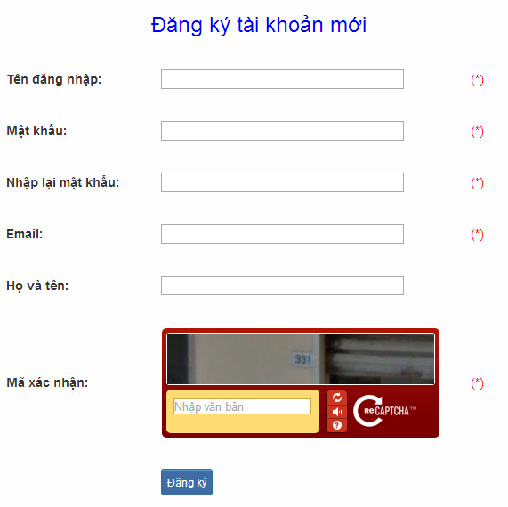

Figure 2.3: Register

Table 2.3: Register’s screen description:

|  |  |  |  |  |  |  |  |
| --- | --- | --- | --- | --- | --- | --- | --- |
| No | Field name | Field name in Vietnamese | Type | Require | Mandatory | Max-Length | Description |
| 1 | Username | Tên đăng nhập | Text | Text | Y | 32 | User input username with length less than 32 characters |
| 2 | Password | Mật khẩu | Password | Text | Y | 32 | User input their password with length less than 32 characters |
| 3 | Re-password | Nhập lại mật khẩu | Password | Text | Y | 32 | User re-input password with length less than 32 characters |
| 4 | Name | Họ và tên | Text | Text | Y | 100 | User input their name with length less than 100 characters |
| 5 | Email | Email | Text | Text | Y | 100 | User input email with length less than 32 characters |
| 6 | Capcha | Mã xác nhận | Text | Text | Y |  | User input the verification code |
| 7 | Register | Đăng ký | Button | Click | Y |  | User click Register button |

## Edit profile

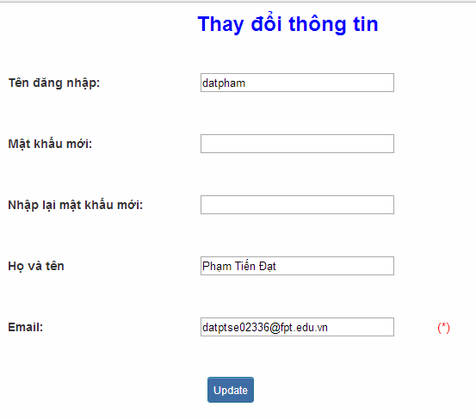

Figure 2.4: Edit profile

Table 2.4: Edit profile’s screen description:

|  |  |  |  |  |  |  |  |
| --- | --- | --- | --- | --- | --- | --- | --- |
| No | Field name | Field name in Vietnamese | Type | Require | Mandatory | Max-Length | Description |
| 1 | Name | Họ và tên | Text | Text | Y | 100 | User input their name with length less than 100 characters |
| 2 | Old-Password | Mật khẩu cũ | Password | Text | Y | 32 | User input their old password with length less than 32 characters |
| 3 | New-password | Mật khẩu mới | Password | Text | Y | 32 | User input new password with length less than 32 characters |
| 4 | Re-password | Nhập lại mật khẩu mới | Password | Text | Y | 32 | User re-input password with length less than 32 characters |
| 5 | Email | Email | Text | Text | Y | 100 | User input email to with length less than 100 characters |
| 6 | Edit | Thay đổi thông tin | Button | Click | Y |  | User click on Edit button |

## Forgot password

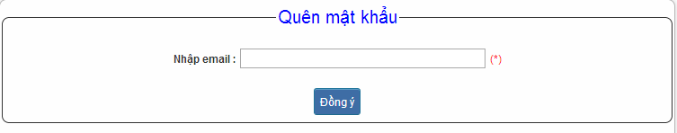

Figure 2.5: Forgot password

Table 2.5: Forgot password’s screen description:

|  |  |  |  |  |  |  |  |
| --- | --- | --- | --- | --- | --- | --- | --- |
| No | Field name | Field name in Vietnamese | Type | Require | Mandatory | Max-Length | Description |
| 1 | Email | Email | Text | Text | Y | 100 | User input email with length less than 100 characters |
| 2 | Send | Đồng ý | Button | Click | Y |  | Click to receive password |

## Contribute content

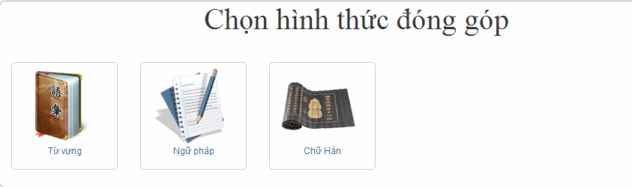

Figure 3.1: Contribute content

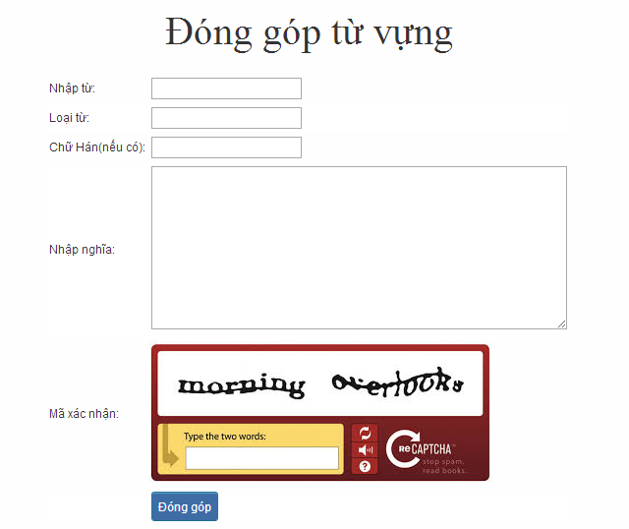

Figure 3.1.1: Contribute vocabulary

Table 3.1: Contribute vocabulary’s screen description:

|  |  |  |  |  |  |  |  |
| --- | --- | --- | --- | --- | --- | --- | --- |
| No | Field name | Field name in Vietnamese | Type | Require | Mandatory | Max-Length | Description |
| 1 | Vocabulary | Từ | Text | Text | Y | 200 | User input vocabulary with length less than 200 characters |
| 2 | Category | Loại từ | Drop-down list | Click | Y |  | User choose type of category |
| 3 | Kanji | Chữ Hán | Text | Text | Y | 10 | User input kanji of vocabulary (if exist) with length less than 10 characters |
| 4 | Mean | Nhập nghĩa | Text | Text | Y | 500 | User input mean of vocabulary with length less than 500 characters |
| 5 | Capcha | Mã xác nhận | Text | Text | Y |  | User input the verification code |
| 6 | Contribute | Đóng góp | Button | Click | Y |  | User click on contribute button |

## Contribute opinion

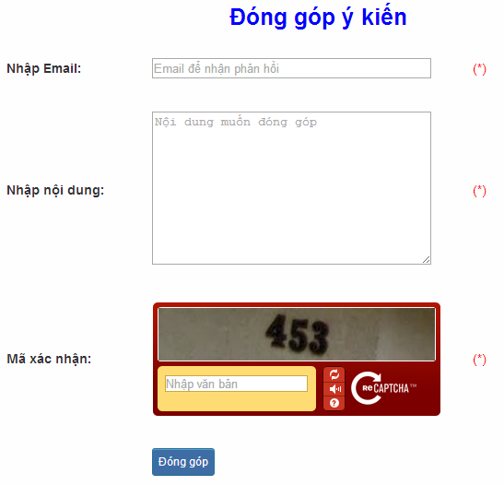

Figure 3.2: Contribute opinion

Table 3.2 : Contribute opinion’s screen description:

|  |  |  |  |  |  |  |  |
| --- | --- | --- | --- | --- | --- | --- | --- |
| No | Field name | Field name in Vietnamese | Type | Require | Mandatory | Max-Length | Description |
| 1 | Email | Email | Text | Text | Y | 100 | User input email with length less than100 characters |
| 2 | Content | Nhập nội dung | Text | Text | Y | 1000 | User input content with length less than1000 characters |
| 3 | Capcha | Mã xác nhận | Text | Text | Y |  | User input the verification code |
| 4 | Contribute | Đóng góp | Button | Click | Y |  | User click on contribute button |

## Send Q&A

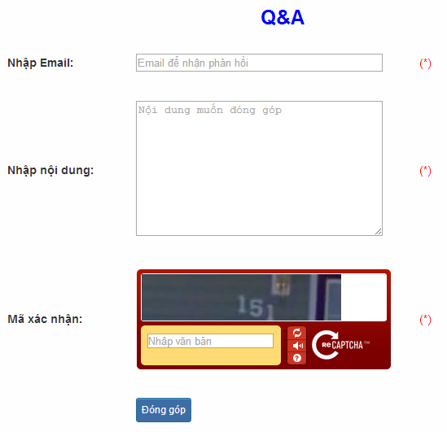

Figure 3.3: Send Q&A

Table 3.3: Send Q&A’s screen description:

|  |  |  |  |  |  |  |  |
| --- | --- | --- | --- | --- | --- | --- | --- |
| No | Field name | Field name in Vietnamese | Type | Require | Mandatory | Max-Length | Description |
| 1 | QA | Q&A | Text | Text | Y | 1000 | User input Q&A with length less than 1000 characters |
| 2 | Email | Email | Text | Text | Y | 100 | User input email with length less than 100 characters |
| 3 | Capcha | Mã xác nhận | Text | Text | Y |  | User input the verification code |
| 4 | Contribute | Đóng góp | Button | Click | Y |  | User click on contribute button |

## Test

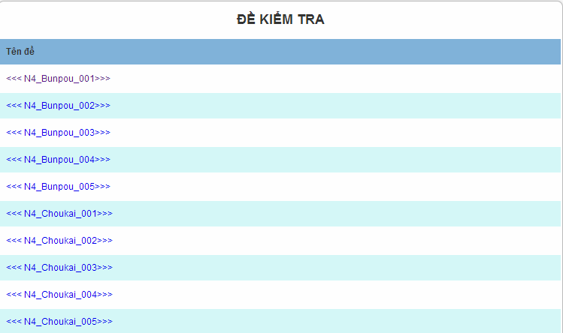

Figure 4.1: Doing test

|  |  |  |  |  |  |  |
| --- | --- | --- | --- | --- | --- | --- |
| No | Field name | Type | Require | Mandatory | Length | Description |
| 1 | N4\_Bunpou\_001 | Hyperlink | Click | N |  | Display information of test |
| 2 | N4\_Bunpou\_002 | Hyperlink | Click | N |  | Display information of test |
| 3 | N4\_Bunpou\_003 | Hyperlink | Click | N |  | Display information of test |
| 4 | N4\_Bunpou\_004 | Hyperlink | Click | N |  | Display information of test |
| 5 | N4\_Bunpou\_005 | Hyperlink | Click | N |  | Display information of test |
| 6 | N4\_Choukai\_001 | Hyperlink | Click | N |  | Display information of test |

## Training listening

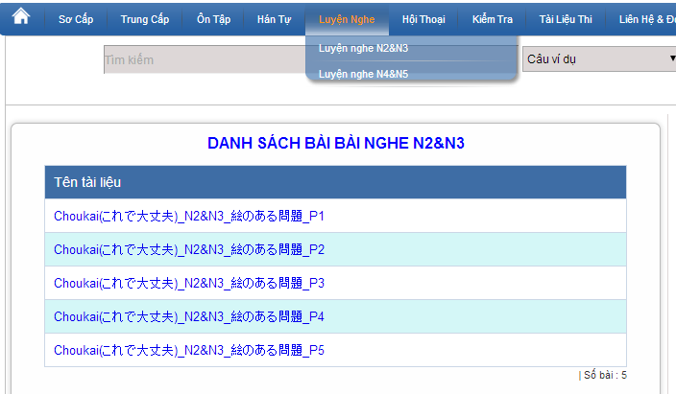

Figure 4.2: Training listening

|  |  |  |  |  |  |  |
| --- | --- | --- | --- | --- | --- | --- |
| No | Field name | Type | Require | Mandatory | Length | Description |
| 1 | Choukai\_P1 | Hyperlink | Click | N |  | Display information of listening |
| 2 | Choukai\_P2 | Hyperlink | Click | N |  | Display information of listening |
| 3 | Choukai\_P3 | Hyperlink | Click | N |  | Display information of listening |
| 4 | Choukai\_P4 | Hyperlink | Click | N |  | Display information of listening |
| 5 | Choukai\_P5 | Hyperlink | Click | N |  | Display information of listening |

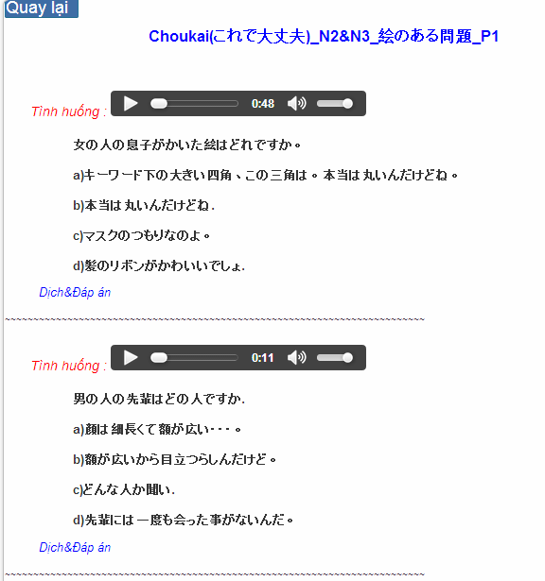

Figure 4.2.1: Training listening content

Table 4.2.1 : Training listening content’s screen description:

|  |  |  |  |  |  |  |
| --- | --- | --- | --- | --- | --- | --- |
| No | Field name | Field name in Vietnamese | Type | Require | Mandatory | Description |
| 1 | Audio | Audio | Audio | Click | Y | User click play button |
| 2 | Translation and Answer | Dịch và đáp án | Link | Click | Y | User click to display translation and answer |

## Conversation

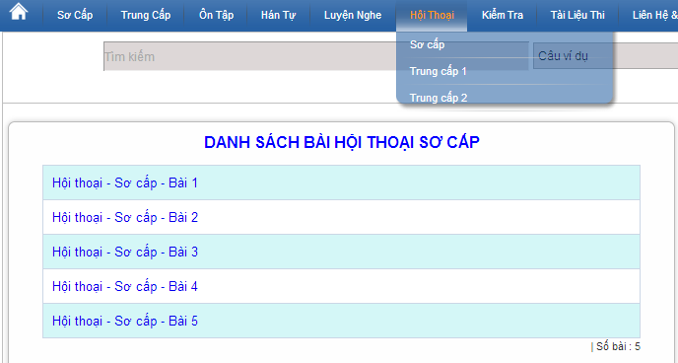

Figure 4.3: Conversation

|  |  |  |  |  |  |  |
| --- | --- | --- | --- | --- | --- | --- |
| No | Field name | Type | Require | Mandatory | Length | Description |
| 1 | SC\_P1 | Hyperlink | Click | N |  | Display information of conversation |
| 2 | SC\_P2 | Hyperlink | Click | N |  | Display information of conversation |
| 3 | SC\_P3 | Hyperlink | Click | N |  | Display information of conversation |
| 4 | SC\_P4 | Hyperlink | Click | N |  | Display information of conversation |
| 5 | SC\_P5 | Hyperlink | Click | N |  | Display information of conversation |

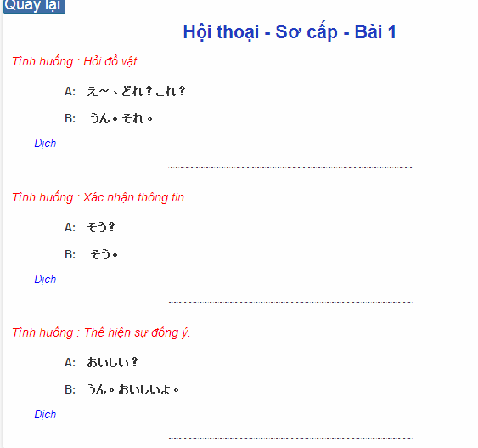

Figure 4.3.1: Conversation content

Table 4.2.1 : Training listening content’s screen description:

|  |  |  |  |  |  |  |
| --- | --- | --- | --- | --- | --- | --- |
| No | Field name | Field name in Vietnamese | Type | Require | Mandatory | Description |
| 1 | Translation | Dịch | Link | Click | Y | User click to display translation |

## Reading

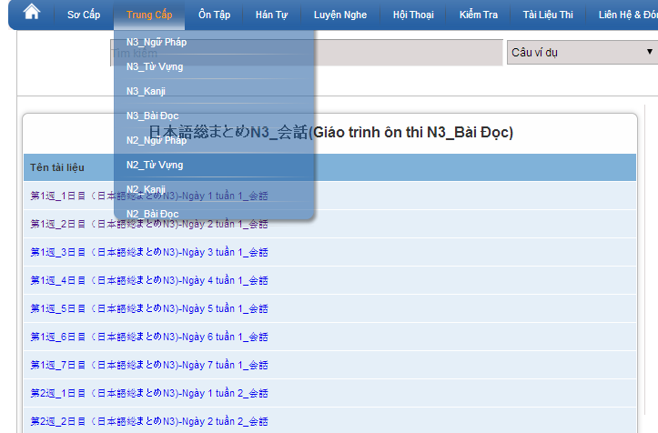

Figure 4.4: Reading document

## Management Member’s account

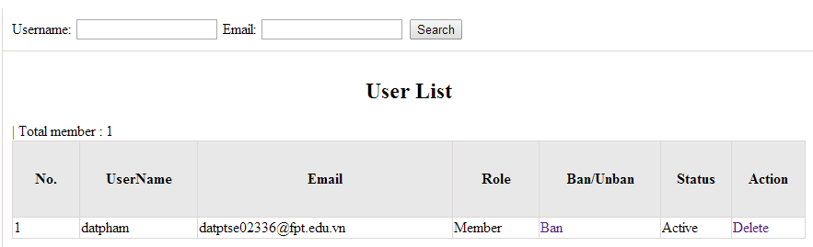

Figure 6: Management Member

Table 6: Management member’s screen description:

|  |  |  |  |  |  |  |
| --- | --- | --- | --- | --- | --- | --- |
| No | Field name | Type | Require | Mandatory | Max-Length | Description |
| 1 | Username | Text | Text | Y | 32 | Admin input username to search member by username |
| 2 | Email | Text | Text | Y | 100 | Admin input email to search member by email |
| 3 | Ban/Unban | Button | Click | N |  | Admin click ban/unban member |
| 4 | Delete | Button | Click | N |  | Admin click delete member |

## Vocabulary management

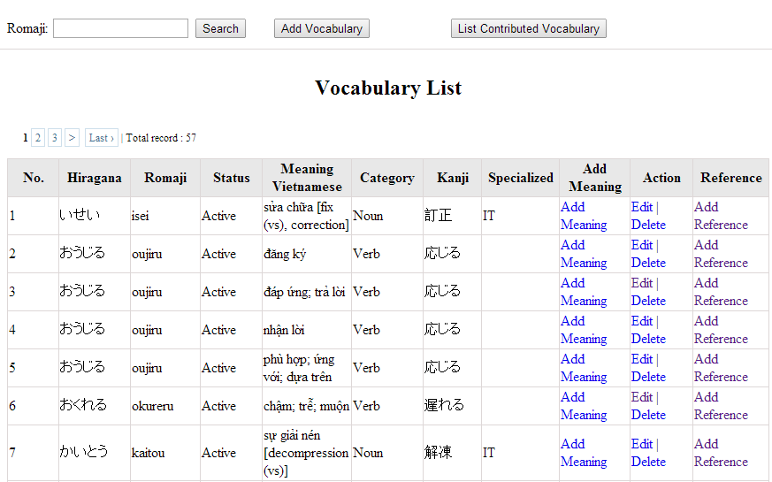

Figure 7: Vocabulary management

Table 7.1: Vocabulary management’s screen description:

|  |  |  |  |  |  |  |
| --- | --- | --- | --- | --- | --- | --- |
| No | Field name | Type | Require | Mandatory | Max-Length | Description |
| 1 | Romaji | Text | Text | Y | 100 | Admin input romaji with length less than 100 character |
| 2 | Search | Button | Click | Y |  | Admin click to search vocabulary |
| 2 | Add-new | Button | Click | N |  | Admin add new vocabulary into database |
| 3 | Add meaning | Button | Click | Y |  | Admin add meaning of vocabulary |
| 4 | Edit | Button | Click | N |  | Admin click edit vocabulary |
| 5 | Delete | Button | Click | N |  | Admin click delete vocabulary |
| 6 | Add-reference | Button | Click | N |  | Admin add reference of vocabulary if reference exist |
| 7 | List-contribute | Button | Click | N |  | Admin click to view list contribute |

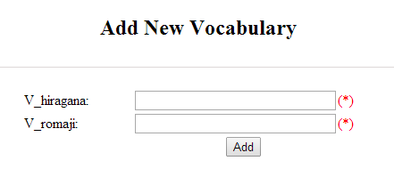

Figure 7.2: Add new vocabulary

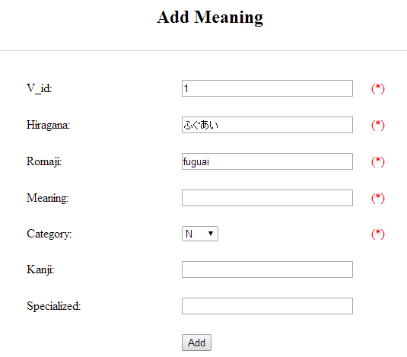

Figure 7.2.1: Add vocabulary meaning

Table 7.2: Add new vocabulary & meaning’s screen description:

|  |  |  |  |  |  |  |
| --- | --- | --- | --- | --- | --- | --- |
| No | Field name | Type | Require | Mandatory | Max-Length | Description |
| 1 | Hiragana | Text | Text | Y | 200 | Admin input vocabulary by hiragana with length less than 200 characters |
| 2 | Romaji | Text | Text | Y | 200 | Admin input vocabulary by romaji with length less than 200 characters |
| 3 | Meaning | Text | Text | Y | 500 | Admin input mean of vocabulary with length less than 500 characters |
| 4 | Category | Drop-down list | Click | Y |  | Admin choose category of vocabulary |
| 5 | Kanji | Text | Text | Y | 10 | Admin input vocabulary by kanji with length less than 10 characters |
| 6 | Specialized | Text | Text | Y | 200 | Admin input specialized of vocabulary with leng less than 200 characters |
| 7 | Add | Button | Click | Y |  | Admin add new vocabulary |

## Grammar management

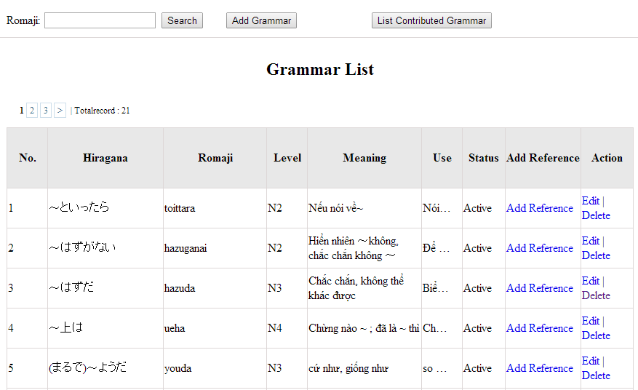

Figrure 8: Grammar management

Table 8.1: Grammar management’s screen description:

|  |  |  |  |  |  |  |
| --- | --- | --- | --- | --- | --- | --- |
| No | Field name | Type | Require | Mandatory | Max-Length | Description |
| 1 | Romaji | Text | Text | Y | 100 | Admin input romaji with length less than 100 character |
| 2 | Add-new | Button | Click | N |  | Admin add new grammar into database |
| 3 | Edit | Button | Click | N |  | Admin click edit grammar |
| 4 | Delete | Button | Click | N |  | Admin click delete grammar |
| 5 | Add-reference | Button | Click | N |  | Admin add reference of grammar |
| 6 | List-contribute | Button | Click | N |  | Admin click to view list contribute |

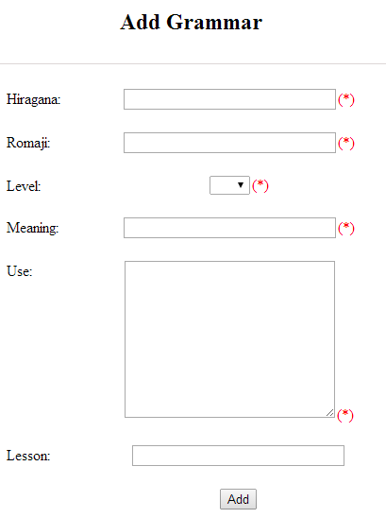

Figure 8.2: Add grammar

Table 8.2: Add grammar’s screen description:

|  |  |  |  |  |  |  |
| --- | --- | --- | --- | --- | --- | --- |
| No | Field name | Type | Require | Mandatory | Max-Length | Description |
| 1 | Hiragana | Text | Text | Y | 200 | Admin input grammar by hiragana with length less than 200 characters |
| 2 | Romaji | Text | Text | Y | 200 | Admin input grammar by romaji with length less than 200 characters |
| 3 | Meaning | Text | Text | Y | 200 | Admin input mean of grammar with length less than 200 characters |
| 4 | Use | Text | Text | Y | 1000 | Admin input use of grammar with length less than 1000 characters |
| 5 | Level | Drop-down list | Choose | Y |  | Admin choose level of grammar |
| 6 | Lesson | Text | Text | Y | 20 | Admin input lesson |
| 7 | Add | Button | Click | Y |  | Admin add new grammar |

## Reading document management

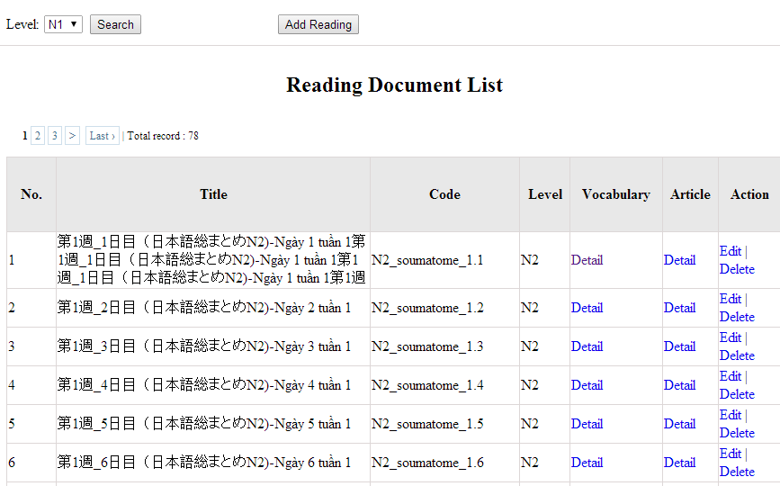

Figure 9: Reading document

Table 9: Reading document’s screen description:

|  |  |  |  |  |  |  |
| --- | --- | --- | --- | --- | --- | --- |
| No | Field name | Type | Require | Mandatory | Max-Length | Description |
| 1 | Level | Drop-down list | Click | Y |  | Admin choose the level |
| 2 | Search | Button | Click | Y |  | Admin click to search |
| 3 | Add-new | Button | Click | N |  | Admin add new into database |
| 4 | Edit | Button | Click | N |  | Admin click edit grammar |
| 5 | Delete | Button | Click | N |  | Admin click delete grammar |
| 6 | Detail-Vocab | Hyperlink | Click | N |  | Details of vocabulary |
| 7 | Detail-Article | Hyperlink | Click | N |  | Details of article |

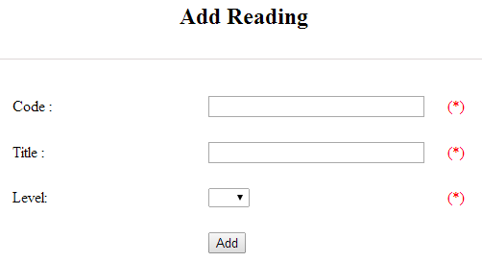

Figure 9.2 : Add reading document

Table 9.2 : Add reading document’s screen description:

|  |  |  |  |  |  |  |
| --- | --- | --- | --- | --- | --- | --- |
| No | Field name | Type | Require | Mandatory | Max-Length | Description |
| 1 | Code | Text | Text | Y | 50 | Admin input code with length less than 50 character |
| 2 | Title | Text | Text | Y | 100 | Admin input title with length less than 100 characters |
| 3 | Level | Drop-down list | Click | Y |  | Admin choose the level |
| 4 | Add | Button | Click | Y |  | Admin click to add reading |

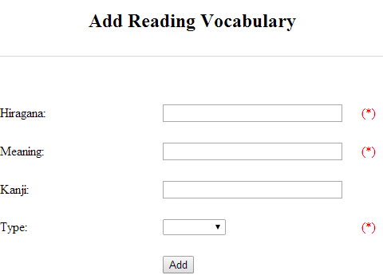

Figure 9.2.1 : Add reading vocabulary

Table 9.2.1 : Add reading vocabulary’s screen description:

|  |  |  |  |  |  |  |
| --- | --- | --- | --- | --- | --- | --- |
| No | Field name | Type | Require | Mandatory | Max-Length | Description |
| 1 | Hiragana | Text | Text | Y | 100 | Admin input hiragana with length less than 100 character |
| 2 | Meaning | Text | Text | Y | 100 | Admin input meaning with length less than 100 characters |
| 3 | Kanji | Text | Text | N | 10 | Admin input kanji with length less than 10 characters |
| 4 | Type | Drop-down list | Click | Y |  | Admin choose the type |
| 5 | Add | Button | Click | Y |  | Admin click to add reading vocabulary |

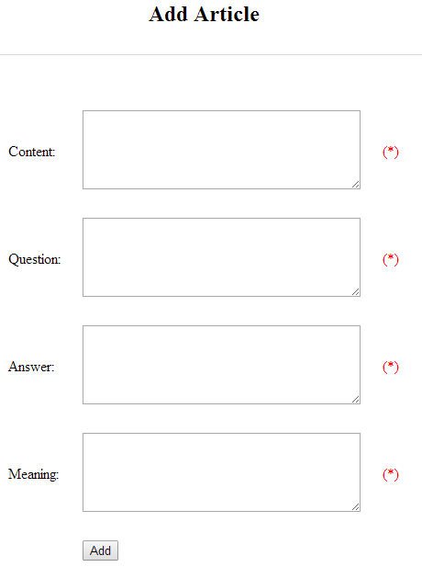

Figure 9.2.2 : Add article

Table 9.2.2 : Add article’s screen description:

|  |  |  |  |  |  |  |
| --- | --- | --- | --- | --- | --- | --- |
| No | Field name | Type | Require | Mandatory | Max-Length | Description |
| 1 | Content | Text | Text | Y | 5000 | Admin input content with length less than 5000 character |
| 2 | Question | Text | Text | Y | 5000 | Admin input question with length less than 5000 characters |
| 3 | Answer | Text | Text | Y | 5000 | Admin input answer with length less than 5000 characters |
| 4 | Meaning | Text | Text | Y | 5000 | Admin input meaning with length less than 5000 characters |
| 5 | Add | Button | Click | Y |  | Admin click to add article |

## Conversation management

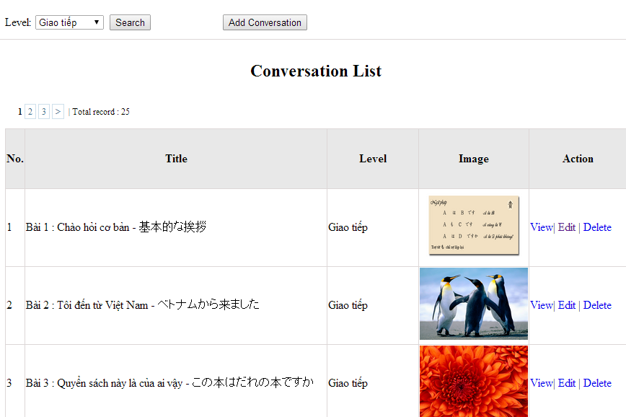

Figure 10: Conversation management

Table 10: Conversation management’s screen description:

|  |  |  |  |  |  |  |
| --- | --- | --- | --- | --- | --- | --- |
| No | Field name | Type | Require | Mandatory | Max-Length | Description |
| 1 | Level | Drop-down list | Click | N |  | Admin choose the level |
| 2 | Search | Button | Click | N |  | Admin click to search conversation |
| 3 | Add-new | Button | Click | N |  | Admin click to add new conversation |
| 4 | View | Hyperlink | Click | N |  | Admin click to view content |
| 5 | Edit | Hyperlink | Click | N |  | Admin click edit conversation |
| 6 | Delete | Hyperlink | Click | N |  | Admin click delete conversation |

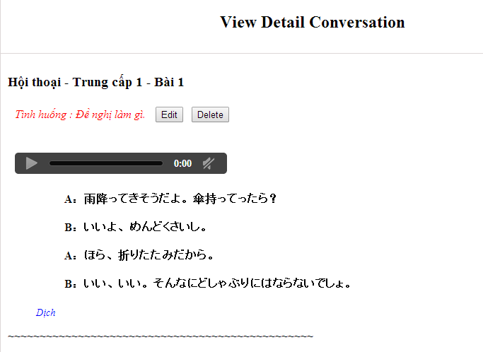

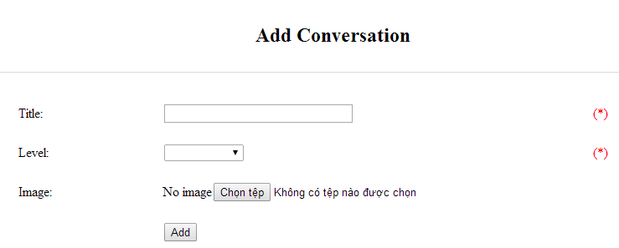

Figure 10.2.1: Add conversation

Table 10.2.1: Add conversation’s screen description:

|  |  |  |  |  |  |  |
| --- | --- | --- | --- | --- | --- | --- |
| No | Field name | Type | Require | Mandatory | Max-Length | Description |
| 1 | Title | Text | Text | Y | 100 | Admin input title of conversation with length less than 100 characters |
| 3 | Level | Drop-down list | Text | Y |  | Admin choose the level |
| 4 | Image | Button | Click | N |  | Admin choose the image |
| 5 | Add | Button | Click | Y |  | Admin add new conversation |

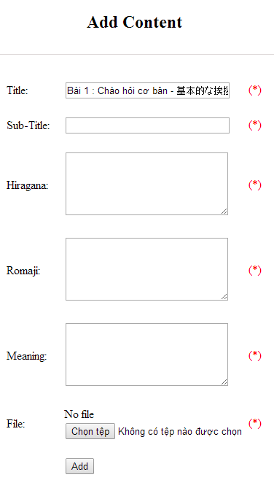

Figure 10.2.2: Add new conversation content

Table 10.2.2: Add conversation content’s screen description:

|  |  |  |  |  |  |  |
| --- | --- | --- | --- | --- | --- | --- |
| No | Field name | Type | Require | Mandatory | Max-Length | Description |
| 1 | Title |  |  |  |  |  |
| 2 | Sub-title | Text | Text | Y | 200 | Admin input subtitle with length less than 200 characters |
| 3 | Hiragana | Text | Text | Y | 5000 | Admin input hiragana with length less than 5000 characters |
| 4 | Romaji | Text | Text | Y | 5000 | Admin input conversation by romaji with length less than 5000 characters |
| 5 | Meaning | Text | Text | Y | 5000 | Admin input conversation’s meaning with length less than 5000 characters |
| 6 | File | Button | Click | Y |  | Admin choose the file |
| 7 | Add | Button | Click | Y |  | Admin add new content |

## Video management

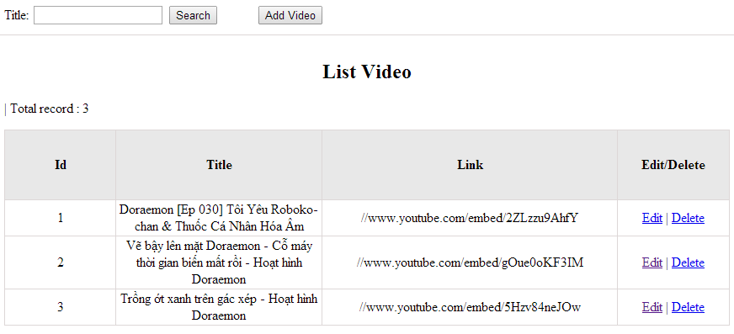

Figrure 11: Video management

Table 11.1: Video management’s screen description:

|  |  |  |  |  |  |  |
| --- | --- | --- | --- | --- | --- | --- |
| No | Field name | Type | Require | Mandatory | Max-Length | Description |
| 1 | Title | Text | Text | Y | 100 | Admin input title with length less than 100 character |
| 2 | Addnew | Button | Click | N |  | Admin add new video into database |
| 3 | Edit | Button | Click | N |  | Admin click edit video |
| 4 | Delete | Button | Click | N |  | Admin click delete video |

## Training listening management

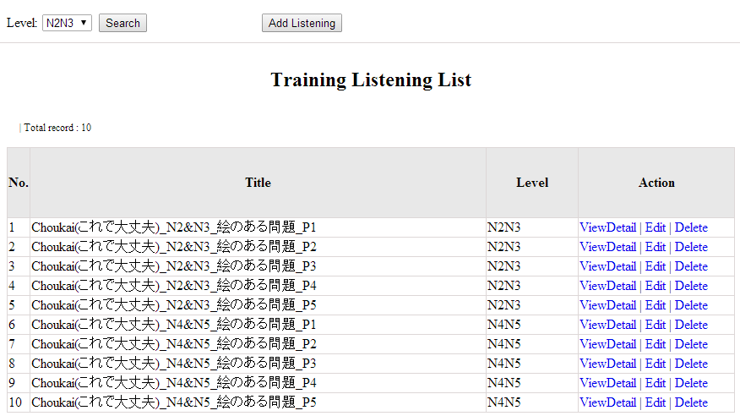

Figure 12: Listening article management

Table 12.1: Conversation management’s screen description:

|  |  |  |  |  |  |  |
| --- | --- | --- | --- | --- | --- | --- |
| No | Field name | Type | Require | Mandatory | Max-Length | Description |
| 1 | Level | Drop-down list | Click | Y |  | Admin choose the level |
| 2 | Search | Button | Click | Y |  | Admin click to search |
| 3 | Addnew | Button | Click | N |  | Admin add new listening into database |
| 4 | ViewDetail | Hyperlink | Click | N |  | Admin click to view details of listening |
| 5 | Edit | Button | Click | N |  | Admin click edit listening article |
| 6 | Delete | Button | Click | N |  | Admin click delete article |

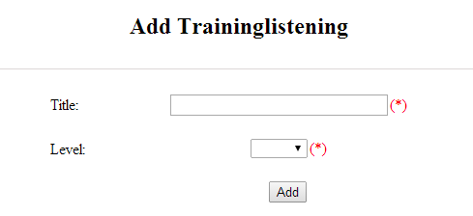

Figure 12.2: Add listening :

Table 12.2: Add listening’s screen description:

|  |  |  |  |  |  |  |
| --- | --- | --- | --- | --- | --- | --- |
| No | Field name | Type | Require | Mandatory | Max-Length | Description |
| 1 | Title | Text | Text | Y | 500 | Admin input id with length less than 500 characters |
| 2 | Level | Drop-down list | Choose | Y |  | Admin choose level |
| 3 | Add | Button | Click | Y |  | Admin add new listening |

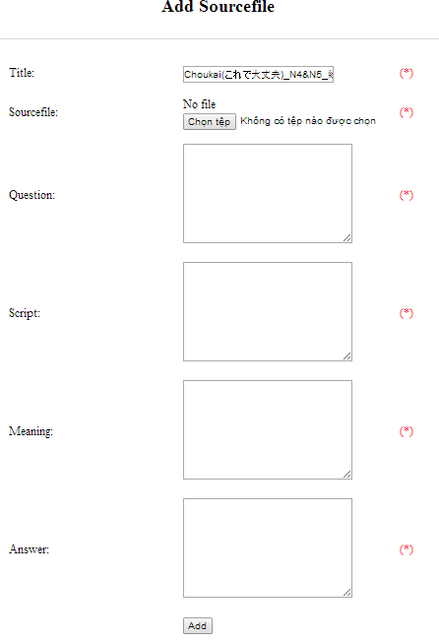

Figure 12.2.1: Add listening source file:

Table 12.2.1: Add listening source file’s screen description:

|  |  |  |  |  |  |  |
| --- | --- | --- | --- | --- | --- | --- |
| No | Field name | Type | Require | Mandatory | Max-Length | Description |
| 1 | Source\_file | Button | Click | Y |  | Admin choose the file |
| 2 | Question | Text | Text | Y | 5000 | Admin input question of listening with length less than 5000 characters |
| 3 | Script | Text | Text | Y | 5000 | Admin input script of listening with length less than 5000 characters |
| 4 | Meaning | Text | Text | Y | 5000 | Admin input meaning of listening with length less than 5000 characters |
| 5 | Answer | Text | Text | Y | 5000 | Admin input answer of listening with length less than 5000 characters |
| 6 | Add | Button | Click | Y |  | Admin add source file |

## Doing test management

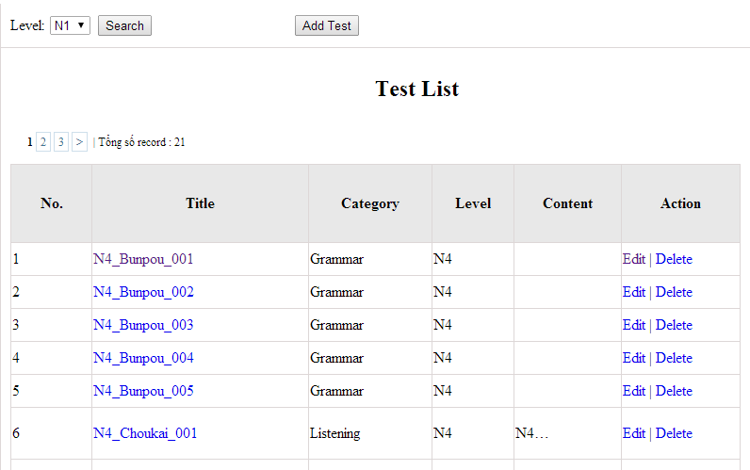

Figure 13: Doing test management

Table 13.1: Doing test management’s screen description:

|  |  |  |  |  |  |  |
| --- | --- | --- | --- | --- | --- | --- |
| No | Field name | Type | Require | Mandatory | Max-Length | Description |
| 1 | Level | Drop-down list | Click | N |  | Admin choose the level |
| 2 | Search | Button | Click | N |  | Admin click to search |
| 3 | List | Hyperlink | Click | N |  | Admin click to view details |
| 4 | Edit | Button | Click | N |  | Admin click edit test |
| 5 | Delete | Button | Click | N |  | Admin click delete test |

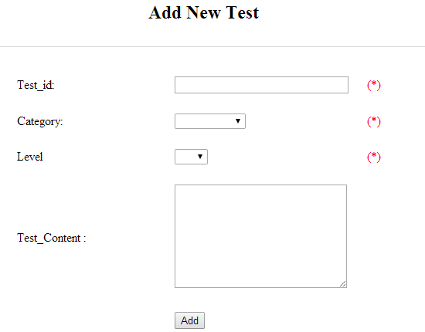

Figure 13.2: Add test

Table 13.2 : Add test’s screen description:

|  |  |  |  |  |  |  |
| --- | --- | --- | --- | --- | --- | --- |
| No | Field name | Type | Require | Mandatory | Max-Length | Description |
| 1 | ID | Text | Text | Y | 100 | Admin input id with length less than 100 characters |
| 2 | Category | Drop-down list | Click | Y |  | Admin choose category |
| 3 | Level | Drop-down list | Click | Y |  | Admin choose level of test |
| 4 | Test content | Text | Text | Y | 5000 | Admin input content with length less than 5000 characters |
| 5 | Add | Button | Click | Y |  | Admin click to add test |

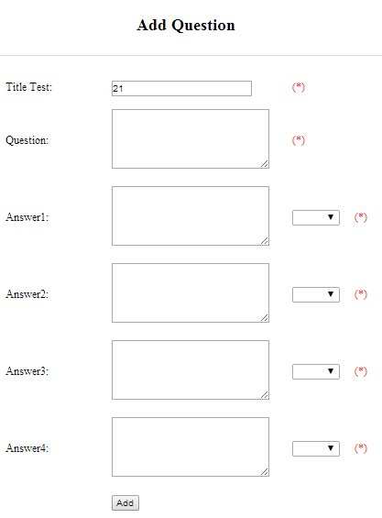

Figure 13.2.1: Add question

Table 13.2.1: Add question’s screen description:

|  |  |  |  |  |  |  |
| --- | --- | --- | --- | --- | --- | --- |
| No | Field name | Type | Require | Mandatory | Max-Length | Description |
| 1 | Question | Text | Text | Y | 200 | Admin input question with length less than 200 characters |
| 2 | Answer 1 | Text | Text | Y | 200 | Admin input answer 1 with length less than 200 characters |
| 3 | Correct answer 1 | Drop-down list | Click | Y |  | Admin choose correct answer |
| 4 | Answer 2 | Text | Text | Y | 200 | Admin input answer 2 with length less than 200 characters |
| 5 | Correct answer 2 | Drop-down list | Click | Y |  | Admin choose correct answer |
| 6 | Answer 3 | Text | Text | Y | 200 | Admin input answer 3 with length less than 200 characters |
| 7 | Correct answer 3 | Drop-down list | Click | Y |  | Admin choose correct answer |
| 8 | Answer 4 | Text | Text | Y | 200 | Admin input answer 4 with length less than 200 characters |
| 9 | Correct answer 4 | Drop-down list | Click | Y |  | Admin choose correct answer |
| 10 | Add | Button | Click | Y |  | Admin click to add |

## Contact management

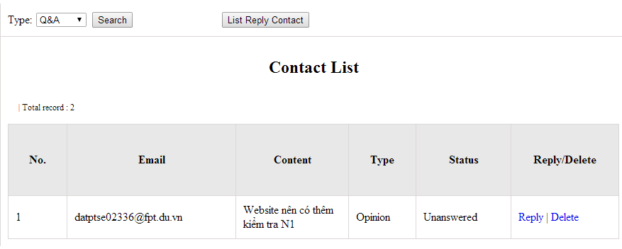 Figure 14.1: Search contact management’s screen

Table 14.1: Search contact management’s screen description

|  |  |  |  |  |  |  |
| --- | --- | --- | --- | --- | --- | --- |
| No | Field name | Type | Require | Mandatory | Max-Length | Description |
| 1 | Type | Drop-down list | Click | N |  | Admin choose the typ |
| 2 | Search | Button | Click | N |  | Admin click to search |
| 3 | Reply | Button | Click | N |  | Admin click reply the question |
| 4 | Delete | Button | Click | N |  | Admin click delete question |
| 5 | List reply | Button | Click | N |  | Admin click to view list reply |

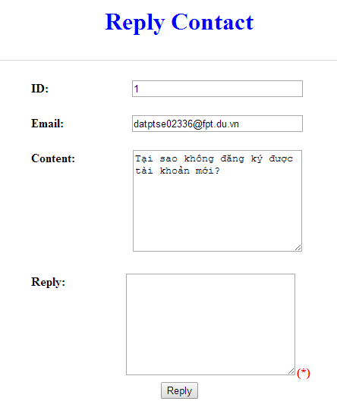

Figure 16.2 : Reply contact

Table 16.2: Reply contact’s screen description:

|  |  |  |  |  |  |  |
| --- | --- | --- | --- | --- | --- | --- |
| No | Field name | Type | Require | Mandatory | Max-Length | Description |
| 1 | Email |  |  |  |  | Email of admin’s account |
| 2 | Content |  |  |  |  | Question |
| 3 | Reply | Text | Text | Y |  | Admin input reply of question |
| 4 | Reply | Button | Click | N |  | Admin click send reply question |

## Approve contribute content

1. Approve contribute kanji screen:

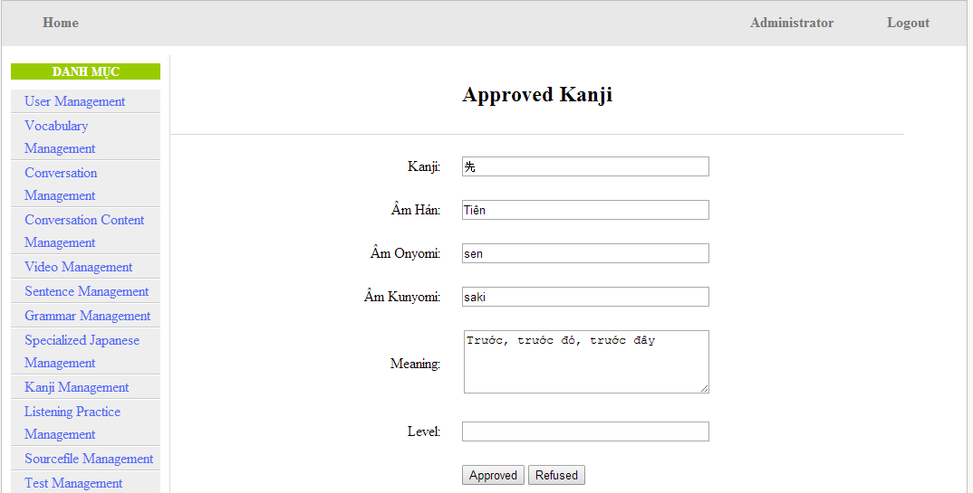

Figure 15.1: Approved kanji’s screen

Table 15.1: Approved kanji’s screen description

|  |  |  |  |  |  |  |  |
| --- | --- | --- | --- | --- | --- | --- | --- |
| No | Field name | File name in Vietnamese | Type | Require | Mandatory | Max-Length | Description |
| 1 | Kanji | Kanji | Text | Text | Y | 10 | Admin input kanji |
| 2 | AmHan | Âm hán | Text | Text | N | 50 | Admin input to the field |
| 3 | Onyomi | Âm Onyomi | Text | Text | Y | 100 | Admin input onyomi |
| 4 | Kunyomi | Âm kunyomi | Text | Text | Y | 100 | Admin input kunyomi |
| 5 | Meaning | Nghĩa | Text | Text | Y | 200 | Admin input meaning |
| 6 | Level | Level | Text | Text | Y | 10 | Admin choose the level |
| 7 | Approved | Approved | Button | Click | N |  | Admin click to approved contribute |
| 8 | Refuse | Refuse | Button | Click | N |  | Admin click to refuse contribute |

1. Approve contribute grammar screen:

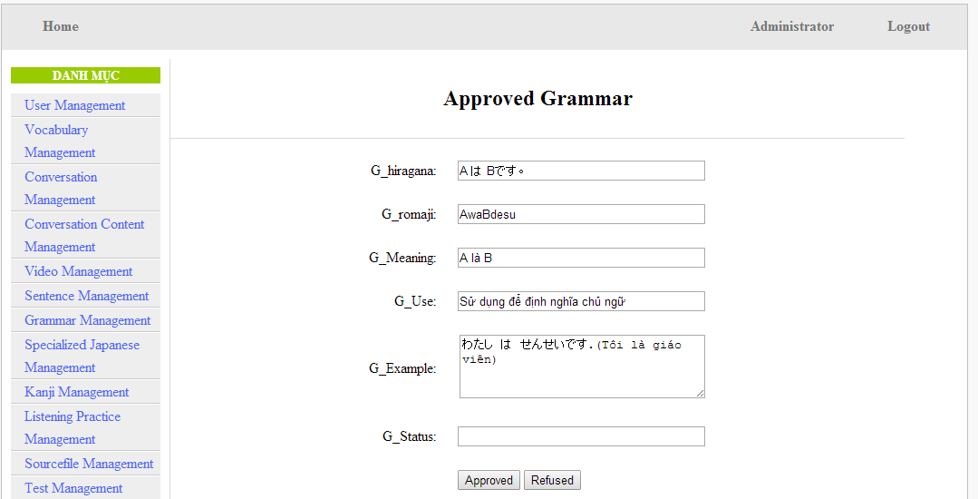

Figure 15.2: Approved grammar screen

Table 15.2: Approved grammar’s screen description:

|  |  |  |  |  |  |  |
| --- | --- | --- | --- | --- | --- | --- |
| No | Field name | Type | Require | Mandatory | Max-Length | Description |
| 1 | Hiragana | Text | Text | Y | 200 | Admin input hiragana |
| 2 | Romaji | Text | Text | N | 200 | Admin input romaji |
| 3 | Meaning | Text | Text | Y | 200 | Admin input meaning |
| 4 | Use | Text | Text | Y | 100 | Admin input kunyomi |
| 5 | Example | Text | Text | Y | 200 | Admin input meaning |
| 6 | Level | Text | Text | Y | 10 | Admin input level of grammar |
| 7 | Approved | Button | Click | N |  | Admin click to approved contribute |
| 8 | Refuse | Button | Click | N |  | Admin click to refuse contribute |

1. Approve contribute vocabulary screen:

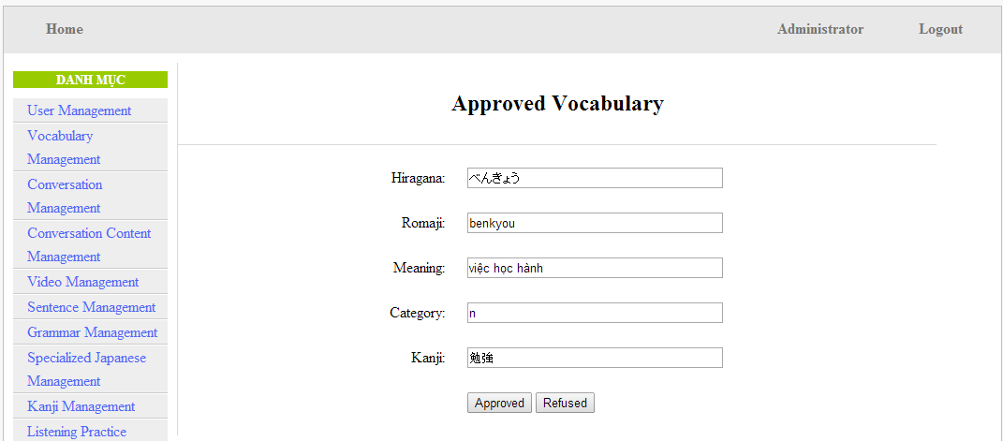

Table 15.3: Approved vocabulary

Table 15.3: Approved vocabulary’s screen description:

|  |  |  |  |  |  |  |
| --- | --- | --- | --- | --- | --- | --- |
| No | Field name | Type | Require | Mandatory | Max-Length | Description |
| 1 | Hiragana | Text | Text | Y | 200 | Admin input hiragana |
| 2 | Romaji | Text | Text | N | 200 | Admin input romaji |
| 3 | Meaning | Text | Text | Y | 500 | Admin input meaning |
| 4 | Category | Text | Text | Y | 10 | Admin choose category |
| 5 | Kanji | Text | Text | Y | 10 | Admin input kanji |
| 6 | Approved | Button | Click | N |  | Admin click to approved contribute |
| 7 | Refuse | Button | Click | N |  | Admin click to refuse contribute |

# Other considerations

**N/A**